403 Parkway, Suite A, Greensboro, NC 27401
336-285-7077

Welcome!

The following is information regarding your first visit at Center for Chiropractic & Wellness. Your appointment has been scheduled under the assumption that your paperwork will have been completed prior to your appointment time.
When filling out the Symptoms Survey form, please follow the directions carefully. Mark the box “1” for mild symptoms, “2” for moderate, and “3” for severe. If the symptom does not apply to you, leave the box blank.

________________________________________________________________________________________________________________
If you arrive without all of your paperwork completed, you will not been seen by the doctor. You will be asked to reschedule.
___________________________________________________________________________

When you come in for your appointment, please:
- Bring your completed New Patient Paperwork (enclosed)
- Bring copies of previous x-ray’s, MRI’s, and lab results
- Please do not wear makeup or fingernail polish on your first visit (will inhibit exam results)
- Please do not chew gum
- Do not drink coffee within 2 hours of your appointment

The fee for your initial visit will depend on your insurance verification. Our office accepts Blue Cross Blue Shield, Cigna, and Medcost. If you do not have health insurance your first initial visit is $70 for your new patient exam and your second visit is $60 for your report of findings and treatment. Please note that most nutrition visits are not covered by insurance. Follow up chiropractic visits are $60 and follow up nutrition visits are $45. We look forward to working with you and re-establishing your health and wellness. If you have any questions, please give our office a call (336) 285-7077.

Best Wishes,
Center for Chiropractic & Wellness Team

Your Wellness History—Intake Form

Welcome to Center for Chiropractic & Wellness. Please be completely accurate and answer each question. Your answers to the following questions are the first step in determining your immediate and long term health care needs. Please elaborate on any question or add any comments you have…the more we know about your needs and concerns, the better we can serve you. Be assured that your information is held in the utmost of confidentiality. Thank you!

Personal Information
Full name: Date:
Address:
City: |  | State: Zip Code:
Primary phone: |  | Work phone:
Email address:
Date of birth: |  | Age:
No. of children: |  | Pregnant? Yes □ No □
Height: |  | Weight:
Marital status: M S W D |  | Spouse/guardian name:
Your Occupation:
Employer’s name:
Spouse’s Occupation/Employer:
Emergency Contact: | Phone:
Relationship to you:

Whom may we thank for referring you, or how did you hear about us?__________________________________________________
What is your primary reason for seeking treatment today? ________________________________________________
___________________________________________________________________________________________________

Addressing What Brought You Into This Office: If you have no symptoms or complaints and are here for Chiropractic Wellness Services, please skip to the “General Health History”.

Health Challenges (including your pain)
Please list your health challenges according to their severity | Rate of severity  1 = mild  10 = worst imaginable | When did this episode start? | If you had this condition before, when? | Did the problem begin with an injury? Or something else? | % of the time pain is present
1.
2.
3.
What type of pain do you feel (Circle all that apply):
Sharp * Dull * Achy * Throbbing * Tingling * Numb * Cramping * Burning * Stiffness * Tightness * Stabbing * Shooting * Electric
Other__________________________________________________________________________________________________________

Does the problem move/radiate to other body parts? If so, where? Arm * Hands * Buttocks * Thigh * Calf * Feet * Ribs * Abdomen * Chest * Head * Neck * Groin
Other__________________________________________________________________________________________________________
Since the problem started is it: About the same? □ Getting better? □ Getting worse? □

Which activities aggravate your condition (Circle all that apply)? * Sitting * Standing * Walking * Lifting * Bending * Lifting * Twisting * Working * Exercising/gentle exercise * Stairs * Lying Down * Other_________________________________________________________________________________________________________

Is this condition interfering with any of the following (CIRCLE ALL THAT APPLY):
*Work *Sleep *Sports/Exercise *Daily Routine *Playing w/Children *Bathing *Running *Housework *Yard work *Hobbies *Lifting *Eating *Dressing *Grooming *Standing *Sitting *Lying down *Sex *Walking
*Other (please explain) ____________________________________________________________________________________________

What offers relief for this condition?
Tylenol * Advil * Aleve * Prescription Drugs * Icy hot * Heat * Ice * Stretching * Exercise * Rest * Movement * Massage Standing * Sitting *Lying down * Home Remedies * Physical Therapy * Surgery
*Other _________________________________________________________________________________________________________

Is there a time of day when your pain is worse or better:____________________________________________________

Have you ever had x-rays taken for this condition?
Area of body: | When? | Where?

Other doctors you have seen for this condition:
Name: | Address:
When did you see them?

Name: |  | Address:
When did you see them?
What was your diagnosis?
Did it help? | What did they do?

Have you been "forced" or "felt the need" to make any "positive" changes in your life due to this pain, illness, condition, etc?
(i.e., eat better, less alcohol or drugs, meditate or breathe more, less destructive sports, activities, etc.) If so, what? ______________________________________________________________________________________________________________________________________________________________________________________________________________________________

General Health History
Often times, accumulation of life’s stress can lead to health problems and influence our ability to heal. Please pay close attention to this as it will help us help you!

Have you had any surgery? (Please include all surgery)
1. Type: | When: | Doctor:
2. Type: | When: | Doctor:
3. Type: | When: | Doctor:

Have you had any accidents and/or injuries: auto, work-related, or other? (Especially those related to your present problems).
1. Type: | When: | Hospitalized: Yes □ No □
2. Type: | When: | Hospitalized: Yes □ No □
3. Type: | When: | Hospitalized: Yes □ No □

Any details about these injuries you would like to elaborate upon:_____________________________________________________
_____________________________________________________________________________________________________________
Do you wear orthotics or heel lifts? Yes □ No □

Current Medicines and Supplements
Please list any medications/drugs you have taken in the past 6 months and why: (prescription and non-prescription)
__________________________________________________________________________________________________________
__________________________________________________________________________________________________________

Please list all nutritional supplements, vitamins, homeopathic remedies you presently take and why:
______________________________________________________________________________________________________________
__________________________________________________________________________________________________________________________________________________________________________________________

Lifestyle factors over a long period of time often affect our health in ways that we may not even be aware of. Please take special care to answer the following questions carefully. Thank you.

Diet -------- Please circle any dietary selection that is appropriate for you, and grade according to the following scale:

D - Consume this daily | FD - Consume this a few times per day | W - Consume this weekly | FW - Consume this a few times per week
FM - Consume a few times per month (less than weekly) | M - Consume this monthly | O - Do not consume this

Alcohol | Eggs | Fasting | Artificial Sweetener
Tobacco | Fruit | Diet food | Weight Control Diet
Coffee/black tea | Beef | Refined Sugar | Raw Vegetables
Soda | Poultry | Fish | Whole Grains
Fried Foods | Organic foods | Seafood | Dairy
Cooked or canned vegetables | Fast Food | Candy | Bread

How much water do you typically drink in a day: __________________________________________________________________
The type of diet I usually follow is classified as: __________________________________________________________________

Please list any allergies: ______________________________________________________________________________________

Please list any food sensitivities: _______________________________________________________________________________

Please list any food cravings that you have: ______________________________________________________________________

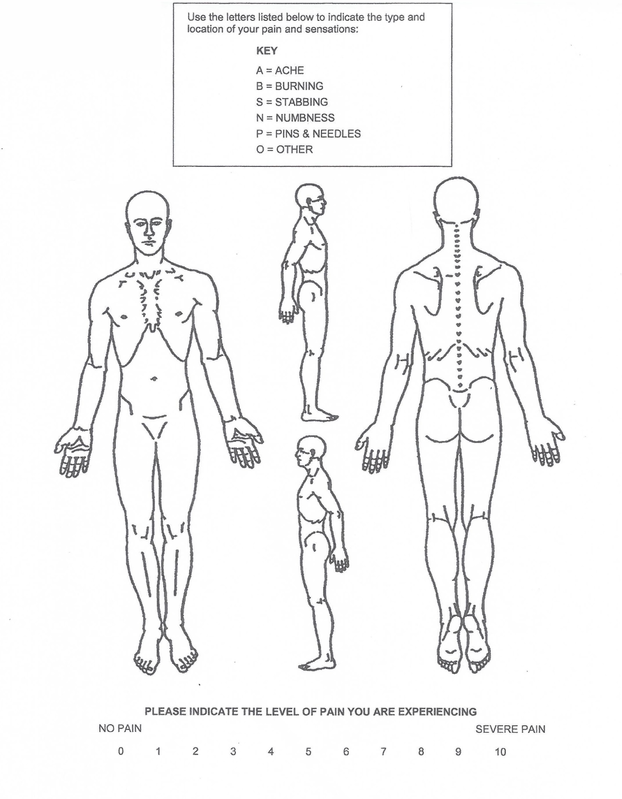
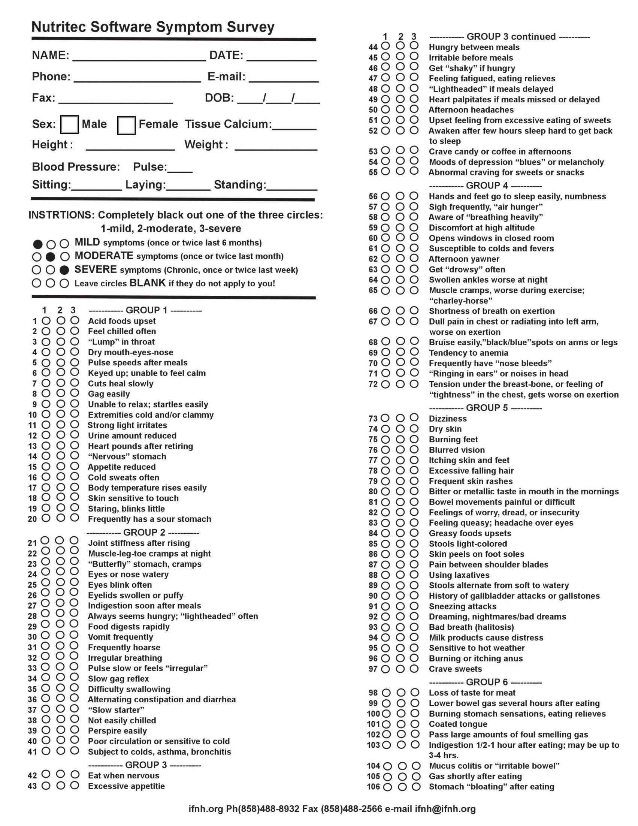
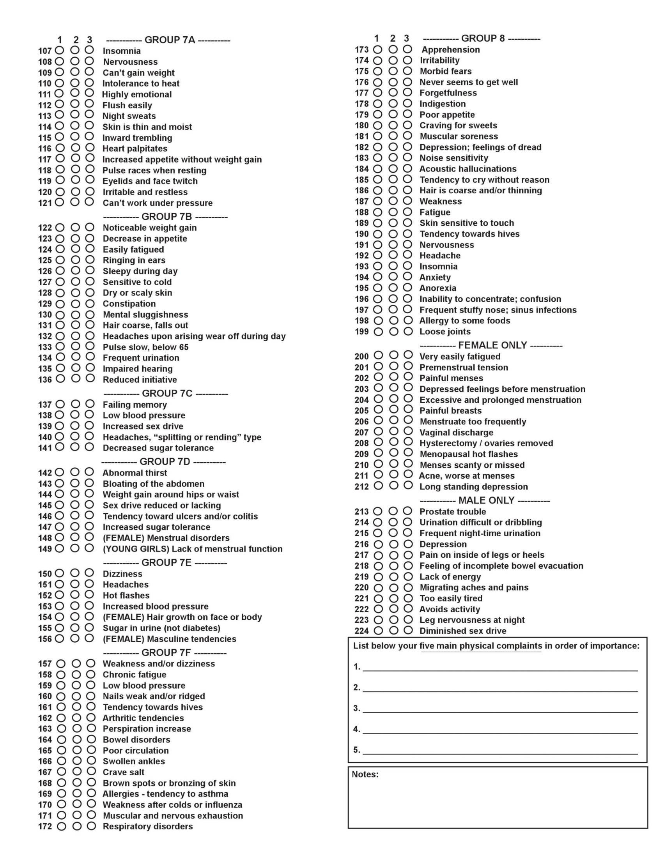Stressors
Because accumulation of stress affects our health and ability to heal please list your top three stresses (you have ever had) in each category:

- Physical stress (falls, accidents, work postures, work injuries, sports injuries, repetitive work postures, etc.)
  - _________________________________________________________________________________________
  - _________________________________________________________________________________________
  - _________________________________________________________________________________________
- Bio-chemical stress (smoke, unhealthy foods, missed meals, don’t drink enough water, medications, drugs/alcohol, etc.)
  - _________________________________________________________________________________________
  - _________________________________________________________________________________________
  - _________________________________________________________________________________________
- Psychological or mental/emotional stress (work, relationships, finances, self-esteem, etc.)
  - _________________________________________________________________________________________
  - _________________________________________________________________________________________
  - _________________________________________________________________________________________

Have you ever suffered from an addiction of any sort: _____________________________________________________________

Have you ever had psychotherapy or counseling? □Yes □No
□Currently being seen □Previously If Previously, from ____________ to _____________
What kind of counseling? ______________________________________________________________________________________

On a scale of 1-10 please grade your present levels of stress (including physical, bio-chemical and psychological or mental/emotional):
At work: | At home: | At play:

On a scale of 1-10, (1 being very poor and 10 being excellent) please describe your:
Eating habits: | Exercise habits: | Sleep: | General health: | Mind set:

How do you grade your physical health:
Excellent □ | Good □ | Fair □ | Poor □ | Getting better □ | Getting worse □

How do you grade your emotional/mental health:
Excellent □ | Good □ | Fair □ | Poor □ | Getting better □ | Getting worse □

For Women:
Date of last PAP_____________ Bone Density Scan____________ Mammogram______________
Age of 1st period (menarche)_____________ Age of last period (Menopause)_____________

For Men:
Date of last prostate checkup____________ PSA results___________ Manual prostate exam results_______________
Lab results______________________________________________________________________________________
For everyone: Have you had or do you have the following sexually transmitted OR contagious diseases: (Please circle all that apply)
*Hepatitis * Tuberculosis * Aids * Herpes * Gonorrhea * Syphilis *HPV *Chlamydia *Herpes 0ther___________________

Family Health History
Does any member of your family have or have had any of the following health conditions:

Diabetes * Heart Disease * Kidney Disease * Cancer * Thyroid Disease * Hypertension * Other

Mother: ______________________________________________________________________
Father: ______________________________________________________________________
Sibling: ______________________________________________________________________
Other: ______________________________________________________________________

Do you have, or have you had any of the following:

Stomach Disorder ___No ___Yes Hiatal Hernia ____ Heartburn ____ Stomach Stapled____ Other____________________
Heart Disease: ___No ___Yes If yes, describe ___________________________________________________________
High Blood Pressure: ___No ___Yes If yes, list medications ___________________________________________________
Cancer: Where? _______________________High Cholesterol/Triglycerides______________________________________
Diabetes: ___No ___Yes If yes, how is it controlled? ________________________________________________________
Thyroid Disease: ___No ___Yes If yes, describe:___________________________________________________________

Have you had any of the following diseases: (Circle all that apply) Anemia Rheumatic Fever Epilepsy Influenza Appendicitis Pneumonia Mumps Pleurisy Measles Whooping Cough Polio Chicken Pox Mental Disorder

What other health or medical challenges/issues do you have:___________________________________________________________

Have you had any of the following organs/glands removed: Gallbladder Uterus or Ovaries Appendix Thyroid Tonsils & Adenoids Any other body part removed:____________________________________________________

Have you ever been treated by a chiropractor, acupuncturist or holistic health practitioner? ____________________________________________________________________________________________________

Please list other problems or concerns you have or had: ______________________________________________________________________________________________________________________________________________________________________________________________________________________________

Are you interested in knowing more about how your nutrition (food you eat) affects your overall health and well-being? | Yes □ No □ Maybe □
If dietary changes are indicated would you be willing to make changes in your diet? | Yes □ No □ Maybe □
Would you take whole food supplements if indicated? | Yes □ No □ Maybe □
If specific exercises or stretching would help would you consider adding them to your program? | Yes □ No □ Maybe □
If reducing stress would you help you would you like to know ways to reduce stress? | Yes □ No □ Maybe □

Is there anything else which may help to better understand your condition which has not been discussed? ______________________________________________________________________________________________________________________________________________________________________________________________________________________________
History of Chief Concern: Please provide an outline of your past experience in treating your primary concern. Note any diagnoses, tests done to confirm the diagnosis, treatments and your response to those treatments. Please include specific therapies done and your response to them. What are your thoughts about the treatments and the outcome? This is only an outline and does not need to be exhaustive as we will discuss during your appointment.
______________________________________________________________________________________________________________
_______________________________________________________________________________________________________________
_______________________________________________________________________________________________________________
_______________________________________________________________________________________________________________
_______________________________________________________________________________________________________________
_______________________________________________________________________________________________________________
_______________________________________________________________________________________________________________
_______________________________________________________________________________________________________________
_______________________________________________________________________________________________________________
_______________________________________________________________________________________________________________
_______________________________________________________________________________________________________________
_______________________________________________________________________________________________________________
_______________________________________________________________________________________________________________
_______________________________________________________________________________________________________________
_______________________________________________________________________________________________________________

I have reviewed this information on the questionnaire and it is accurate to the best of my knowledge. I understand that this information will be used to determine appropriate and healthful treatment. If there is a change in my medical status, I will inform my treating physician.

Signature______________________________________ Date _______________________
Nutrition Consulting Informed Consent
I hereby request and consent to nutritional care/consulting on me (or on the client named below, for whom I am legally responsible) provided by the health practitioner and/or his/her staff.
I understand and am informed that the nutrition consultations may not be made by medical physicians and do not dispense medical advice, diagnose illness or disease, offer prescription drugs, surgery, or other conventional treatments.
I understand and am informed that the nutrition consultations offer nutritional evaluations, nutritional supplementation, and lifestyle consultation along with various methods of testing. I further understand and am informed that the recommendations, discussion, sale of food, nutrition, nutritional supplements, vitamins or minerals, food grade herbs, or other nutrients as foods for special dietary use only provided by the health practitioner and/or his/her staff pertain to the whole body concept of nutrition, and does not relate in the context of any specific ailment or condition.
I understand and am informed that methods of nutritional evaluation or testing made available to me are not intended to diagnose disease. Rather, these assessment tests are intended as a guide to developing an appropriate overall health-supportive program for me, and to monitor my progress in achieving my goals. I further understand that any nutritional recommendations are supportive in nature allowing the body to return to improved health. However, like all other health modalities, results are not guaranteed and there is no promise to cure. Accordingly, I understand that all payment(s) for treatment(s) are final and no refunds will be issued. However, prorated fees for unused, prepaid treatments will be refunded if you wish to cancel the treatment. Products are only refundable if they are unopened and in original condition, including not past their expiration date.
I understand and am informed that the nutritional supplements, vitamins, minerals, food grade herbs, and other nutrients that have been recommended are traditionally considered safe in the practice of nutrition, however, some nutritional supplements, vitamins, minerals, food grade herbs, and other nutrients may be toxic in large doses. I understand that some nutritional supplements, vitamins, minerals, food grade herbs, and other nutrients may be inappropriate during pregnancy, and I will notify the health practitioner and/or his/her staff if I am or become pregnant.
I will also inform the health practitioner and/or his/her staff if I experience any gastrointestinal upset (including but not limited to nausea, gas, stomachache, vomiting), allergic reactions (including but not limited to hives, rashes, tingling of the tongue, headache), or any unanticipated or unpleasant effects associated with the nutritional supplements, vitamins, minerals, food grade herbs, and other nutrients recommended by the health practitioner and/or his/her staff.
I have had an opportunity to ask questions about its content, and by signing below I agree to the above-named services. I intend this consent to cover the entire course of nutritional care/consulting.
I, _____________________________ have read, or have had read to me, the above consent.
(Print Name)
_________________________________________ ___________________________________
(Signature) (Date)

CENTER FOR CHIROPRACTIC & WELLNESS OFFICE POLICIES

******Please read all of these thoroughly before signing******

- PAYMENT/COPAYMENT IS DUE IN FULL WHEN SERVICES ARE RENDERED. PRE-PAYMENTS AND PAYMENT PLANS MAY BE ACCEPTED ON A CASE-BY-CASE BASIS. A general schedule of services and fees are available by inquiring at the front desk. Payments can be made by cash, check, debit card, credit card, health savings, or flex spending accounts.
- Please call us if you need to cancel or reschedule an appointment. If a patient misses or cancels an appointment without 24 HOURS NOTICE, he/she will be responsible for a CANCELLATION FEE OF $45.
- If the patient discontinues care for any reason, any balance is due and payable immediately, regardless of claims submitted. Any medical records including x-rays will not be released until the bill is paid in full.
- In the event that a patient’s account is delinquent, an overdue notice will be sent his/her address on file. If payment is not received within 30 days of the notice date, a 1.5% per month service charge will be incurred until paid in full.
- Products purchased from this office are 100% REFUNDABLE within 7 days if the products are returned unopened.
- There will be an additional $25 fee for returned or NSF checks.
- Depending on the patient’s insurance plan and coverage, this office will bill claims for him/her. This is a courtesy extended by this office and may be withdrawn at any time. The patient can opt to not bill his/her insurance in the state of North Carolina.
- All insurance and contact information must be given to our office at the time of the patient’s first visit. If any of this information changes, it is the patient’s responsibility to notify the front desk immediately.
- If the patient’s insurance has a deductible, it will be assessed based on the charges incurred at this office.
- This office does not guarantee any insurance company will or should make partial or full payment of fees charged. All claims are subject to review for coverage.
- It is not this office’s obligation to enter into a dispute with an insurance company concerning payment.
- If 6 months or more lapse between a patient’s chiropractic treatments, the next appointment scheduled will automatically be a chiropractic re-examination, which incurs an additional fee.
- Nutrition consultations, exercise consults or supplement charges are due at the time of service. These are cash services, not covered by any insurance or third party payors.
- Laboratory testing (varies by company) may or may not be covered by your insurance.
- Medicare covers spinal adjustments only and does not cover any exams, x-rays, re-exams, modalities, extremity adjustments, supports or supplements. If you receive any of these non-covered services or supplements, it is your responsibility to pay the complete cost at the time received. Medicare also doesn’t cover Maintenance or Wellness care. If you choose these services, these are paid out of pocket at the Medicare rate.

It is our wish that each and every one of our patients receives the very best care and service possible. Your Treatment Program consists of a specific series of treatments given over a pre-planned time span. If you cannot follow this plan, then you will not receive the desired results.

If we did not insist that you meet all of your appointments, we would be doing you a disservice and it would be indicative that we did not care. We do not want to do you a disservice and we do care about you and the success of your program here. Therefore, we have a few simple rules that we insist you follow:

- Meet all of your scheduled appointments. Arrange the activities in your life so that this can occur.
- If you become ill, we still want you to come in, because your treatment will help you recover.
- If you are unable to make it due to an emergency, please call and let us know so that we can reschedule your appointment
- With the exception of unexpected emergencies, please call and let us know at least 24 hours in advance to change the appointment.
- All canceled or missed appointments must be rescheduled and made up within 1 week.
- Service charges for missing an appointment are as follows:

15 min. Chiropractic/Nutrition Appointment $45
30 min. Chiropractic/Nutrition Appointment $60

* Note: Confirmation calls are made the day before each patient’s appointment. These calls are a courtesy service, meant to remind patients of their appointment times. However, failure to receive a call does NOT validate a missed appointment.

Patient Signature ___________________________________ Date_________________

CENTER FOR CHIROPRACTIC & WELLNESS
403 Parkway, Suite A
Greensboro, NC 27401
336-285-7077

(Consent to use PHI) Notice of Privacy Practices - Acknowledgement & Consent
Acknowledgement for Consent to Use and Disclosure of Protected Health Information

Use and Disclosure of your Protected Health Information
Your Protected Health Information will be used by Center for Chiropractic & Wellness or may be disclosed to others for the purposes of treatment, obtaining payment, or supporting the day-to-day health care operations of this office.

Notice of Privacy Practices
You should review the complete Notice of Privacy Practices for more description of how your Protected Health Information may be used or disclosed. It describes your rights as they concern the limited use of health information, including your demographic information, collected from you and created or received by this office. You may review the Notice prior to signing this consent. You may request a copy of the Notice at the Front Desk. We reserve the right to change our privacy practices as described in that notice. If we make a change to our privacy practices, we will notify you in writing when you come in for treatment or by mail. Please feel free to call us at any time for a copy of our privacy notices.

Our Privacy Pledge
We are very concerned with protecting your privacy. While the law requires us to give you this disclosure, please understand that we have, and always will, respect the privacy of your health information.

There are several circumstances in which we may have to use or disclose your health care information.
- We may have to disclose your health information to another health care provider or a hospital if it is necessary to refer you to them for the diagnosis, assessment, or treatment of your health condition.
- We may have to disclose your health information and billing records to another party if they are potentially responsible for the payment of your services.
- We may need to use your health information within our practice for quality control or other operational purposes.
- Your chiropractor and members of the practice staff may need to use your name, address, phone number, and your clinical records to contact you with appointment reminders, information about treatment alternatives, or other health related information that may be of interest to you. If this contact is made by phone and you are not at home, a message will be left on your answering machine.

Requesting a Restriction on the Use or Disclosure of Your Information
- You may request a restriction on the use or disclosure of your Protected Health Information at any time.
- This office may or may not agree to restrict the use or disclosure of your Protected Health Information.
- If we agree to your request, the restriction will be binding with this office. Use or disclosure of protected information in violation of an agreed upon restriction will be a violation of the federal privacy standards.

Revocation of Consent
You may revoke this consent to the use and disclosure of your Protected Health Information. You must revoke this consent in writing. Any use or disclosure that has already occurred prior to the date on which your revocation of consent is received will not be affected. If you were required to give your authorization as a condition of obtaining insurance, the insurance company may have a right to your health information if they decide to contest any of your claims.

By my signature below I give my permission to use and disclose my health information.

Patient or Legally Authorized Individual Signature |  |  |  | Date
Print Patient’s Full Name |  |  |  | Time
Witness Signature |  |  |  | Date

